SQL Triggers

Samantha Krall

SYM-400

CREATE TRIGGER [Person].[trgUpdateColumns]

ON [Person].[Person]

FOR UPDATE

AS

SET NOCOUNT ON

DECLARE @i AS int, @num_cols AS int

DECLARE @updCols TABLE(ordinal_position int NOT NULL PRIMARY KEY)

SET @num_cols =

(SELECT COUNT(*)

FROM INFORMATION_SCHEMA.COLUMNS

WHERE TABLE_SCHEMA = 'Person'

AND TABLE_NAME = 'Person')

SET @i = 1

WHILE @i <= @num_cols

BEGIN

IF(SUBSTRING(COLUMNS_UPDATED(), (@i - 1) / 8 + 1, 1))

& POWER(2, (@i - 1) % 8) = POWER(2, (@i -1) % 8)

INSERT INTO @updCols VALUES (@i)

SET @i = @i + 1

END

SELECT COLUMN_NAME AS Updated_Column, GETDATE() AS DateModified

FROM INFORMATION_SCHEMA.COLUMNS AS C JOIN @updCols AS U

ON C.ORDINAL_POSITION = U.ordinal_position

WHERE TABLE_SCHEMA = 'Person'

AND TABLE_NAME = 'Person'

ORDER BY C.ORDINAL_POSITION

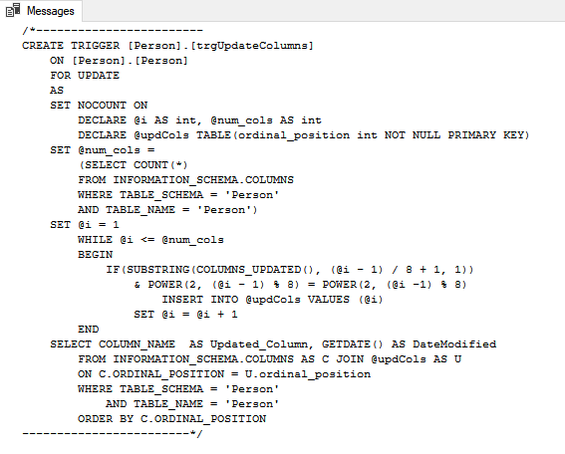 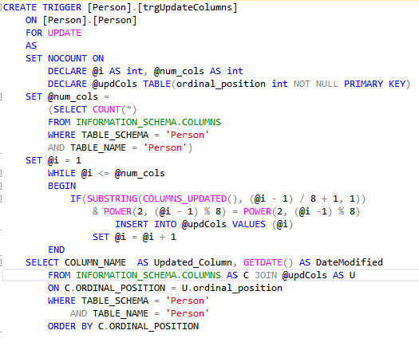

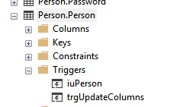

UPDATE Person.Person

SET Title = 'MR.'

WHERE FirstName = 'Ken'

AND MiddleName = 'J'

AND LastName = 'Sánchez'

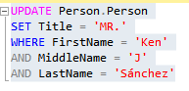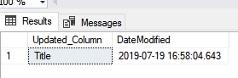

UPDATE Person.Person

SET MiddleName = 'Timothy'

WHERE FirstName = 'Michael'

AND LastName = 'Raheem'

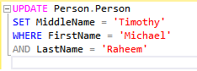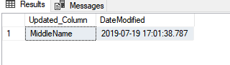

UPDATE Person.Person

SET Title = 'Mrs.', MiddleName = 'Heather'

WHERE FirstName = 'Samantha'

AND LastName = 'Smith'

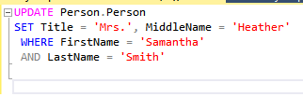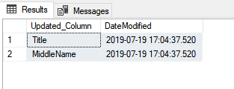

UPDATE Person.Person

SET Title = 'Mrs.', LastName = 'Thompson'

WHERE FirstName = 'Lori'

AND MiddleName = 'K'

AND LastName = 'Penor'

